Exercise no: 1 regno:1518102098

Date:15.10.20

**Aim**

To print the calendar of a given month and year

**Program**

import calendar

year=int(input())

month=int(input())

if(year<10000 and year>999 and month<13 and month>0):

print(calendar.month(year,month))

else:

print("Invalid input")

**Link**

http://103.53.53.18/mod/vpl/forms/edit.php?id=229&userid=1703

**output**

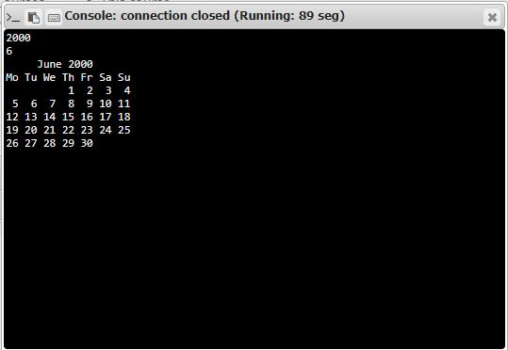

**Result**

Thus,the code has been sucessfully executed and output is verified.